Họ và tên: Nguyễn An Phúc – 21NS – MSV 21IT639

Lab 5: Network Configuration

14.2 Exploring the Network

Step 1:

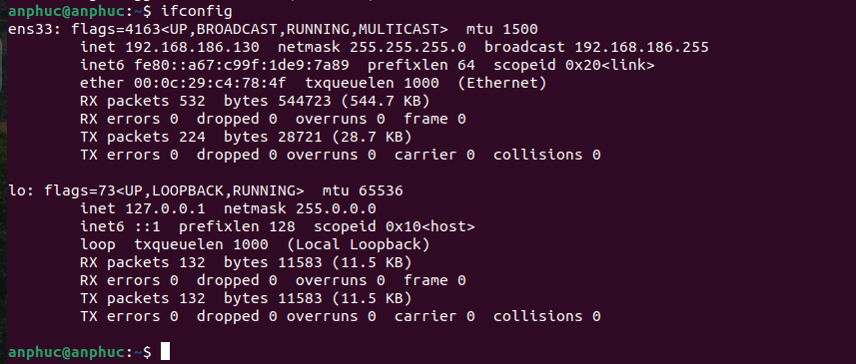

Step 2:

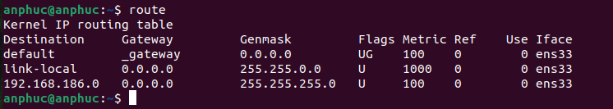

Step 3:

Step 4:

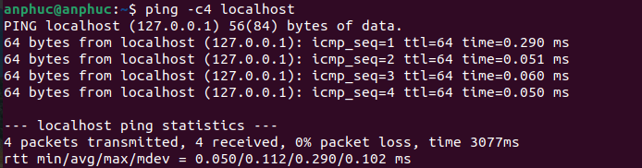

Step 5:

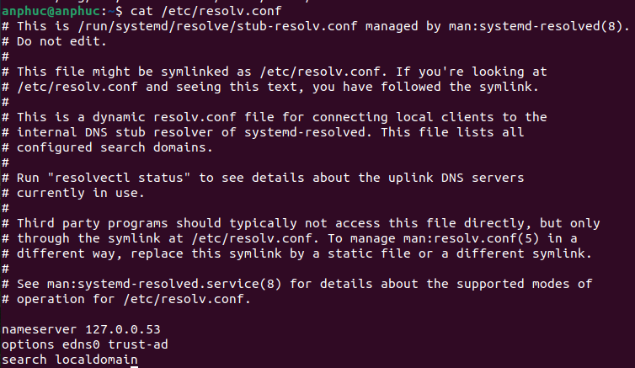

Step 6:

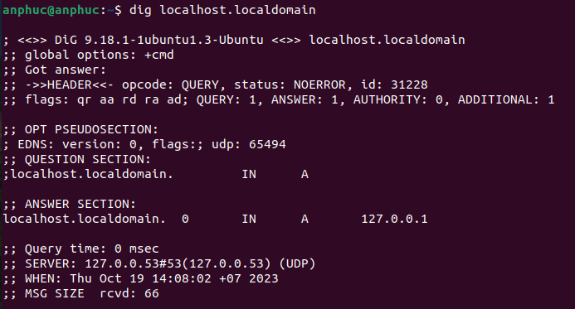

Step 7:

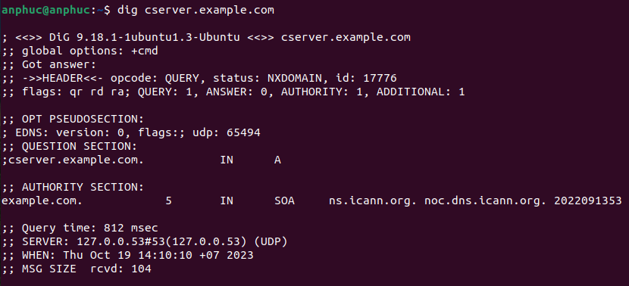

Step 8:

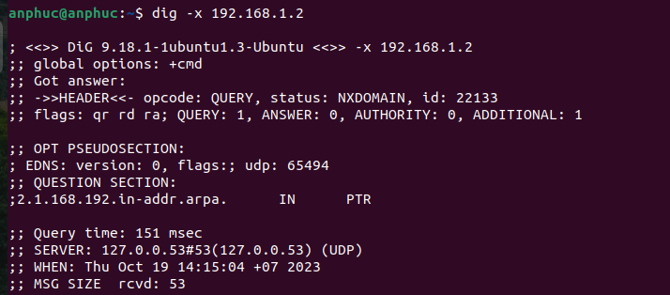

Step 9:

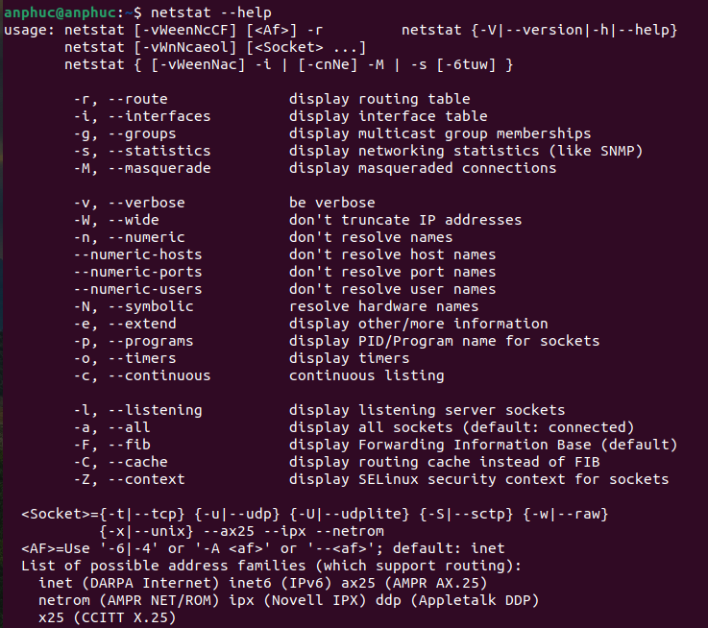

Step 10:

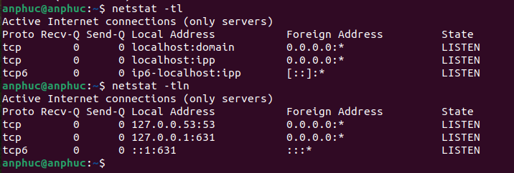

Step 11:

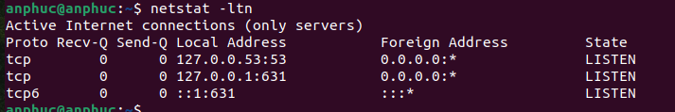

Step 12:
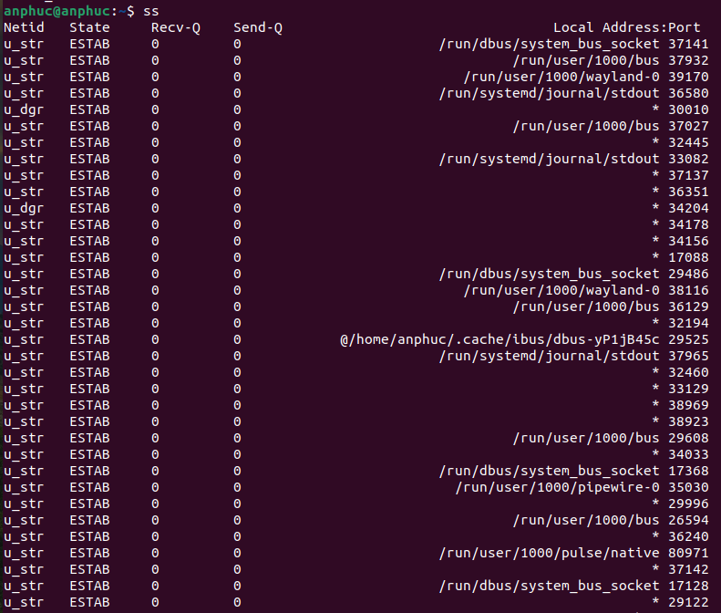

Lab 6: System and User Security

15.2 Running Commands as an Administrator

Step 1:
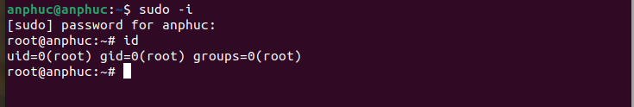

Step 2:
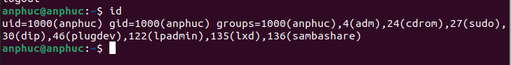

Step 3, 4:


15.3 User Accounts

Step 1:
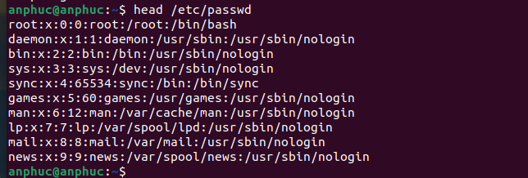

Step 2:

15.4 Passwords

Step 1:

Step 2:

STEP 3:
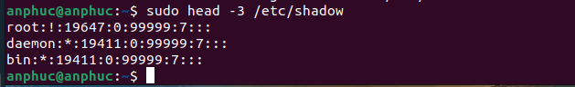

STEP 4:

STEP 5:
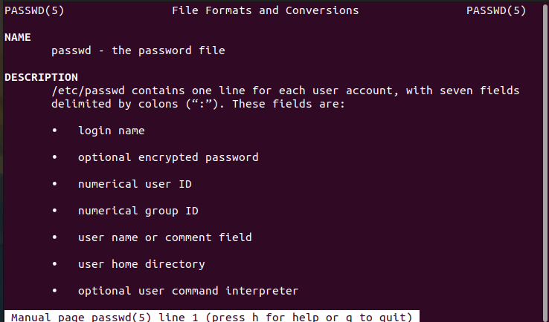

STEP 6:
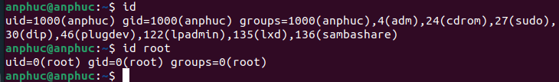

15.5 Who is On the System

Step 1:


Step 2:
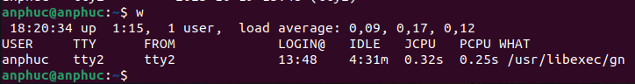

15.6 Viewing Login History

Step 1:

